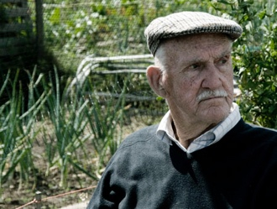

Many of you will have known Len Moakes who had an allotment here for 54 years and lived nearby with his wife Joan in West Dulwich. Sadly Len died on Friday April 27th 2018 aged 95 He described having an allotment in 2008 as “a way of life” and was often on his plot every day. His standards were very high and many of us have benefitted from his advice, gleaned over his many years of growing vegetables and flowers. He has remained active cultivating the plot until very recently with support from his daughter Glenda and his son Bill. Len’s funeral will be at St Stephen’s Church, College Road at 12.30pm on Wednesday 23rd May. If you would like to attend please contact
Glenda on 07786557424 or by
email at glenda@g-m-developments.co.uk

