GREEN MUSINGS FROM THE GRANGE

Taking care of our bees

Wherever you have a space fallow or an empty bed think about scattering seeds of Phacelia Tanacetifolia (available from: <https://www.organiccatalogue.com/popular-now/phacelia-tanacetifolia-100g-organic-seeds.htm>)

Phacelia is so easy to germinate, makes amazing green manure and is loved - no actually ADORED by bees - both bumble and honey bees. Here is a little darling on my

phacelia today 22nd October 2017.

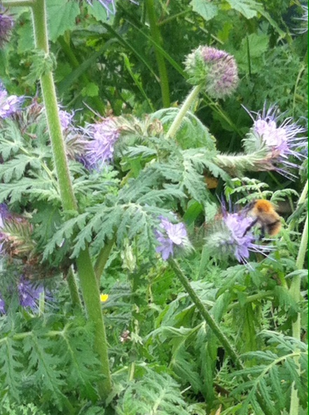

Hedgehog heaven

There is apparently a hedgehog or two in Dulwich woods. They are our friends and will support us in our attempts to keep slugs and snails off our seedlings. However in order to attract them we must ensure we don’t kill them by using slug pellets which contain METALDEHYDE. Please check your slug pellet labels and safely dispose of any containing this poison

MacRix:Users:rix:Desktop:SLUG PELLETS KILL.pdf

Hedgehog havens

Maybe a better thing to do with our woody garden waste is not to burn it, or take it to the town dump, but instead we could provide a safe haven for hedgehogs all along the top fence.

By leaving our woody waste abutting the Dulwich woods fence - in orderly heaps - we would be helping hedgehogs find good safe haven and would encourage them onto our site. Watch this short video to see what else we can do to encourage hedgehogs to return to our site:

<https://youtu.be/ZMVWPvhFrpw>

Habitat heaps

Why are we so obsessed with bonfires? If we did less burning and more heaping we would make

a) amazing habitat for invertebrates, hibernating mammals and most importantly insects

b) wonderful slow releasing compost and

c) these delightful old school hay ricks which look picturesque as well as being such a habitat resource. Here are some from The Habitat Heapers of Grange Lane :

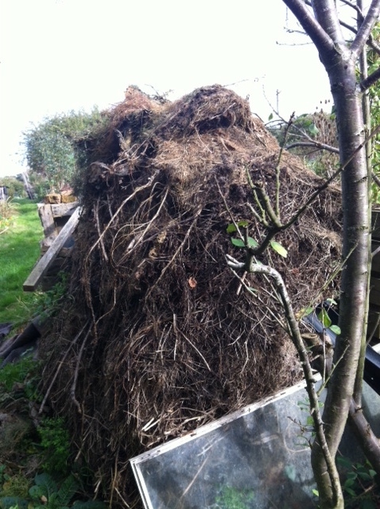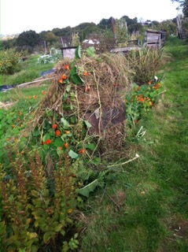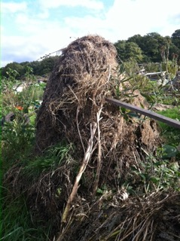

Slugging it out!

If we are to hope to see those lovely thrushes again or the hedgehogs and the frogs and toads we will have to manage our relationship with slugs. Keeping a balance with as many benign methods to keep them off our seedlings involves patience and perseverance – but not toxic pellets!

Slugs don’t like rosemary, lavender, nasturtium or california poppy so you can plant lots of those or cut sprigs and lay around your beds

They love beer so you can half bury small yoghourt pots or similar and fill with beer and then deal with the slug sludge when you next go up.

The greenest and safest slug killer is the nematode control:

[Nemaslug Slug Killer The Natural Organic Slug Control using ...](https://www.greengardener.co.uk/product.asp?id_pc=22&cat=35)

<https://www.greengardener.co.uk/product.asp?id_pc=22&cat=35>

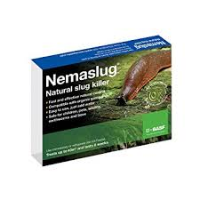 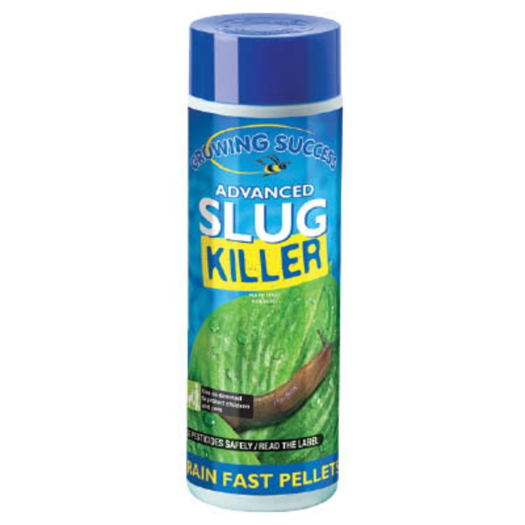

The next safest is probably Advanced Slug Killer from The Organic Catalogue <https://www.organiccatalogue.com/stop-the-pests/slugs-and-snails-top/advanced-slug-killer-575g.htm> made of ferric phosphate and it says: Birds, hedgehogs and other wildlife that eat slugs and snails will not be harmed, unlike with other commonly available slug pellets.

**.**Damp Ditches

If you are suffering from waterlogging in your plot – especially those at the bottom of the hill – please take a look at this:

<https://ww2.rspb.org.uk/get-involved/activities/give-nature-a-home-in-your-garden/garden-activities/digadampditchfordiversity/>

It seems it is very easy to make a damp ditch. Damp ditches not only drain the waterlogged areas, but also make a wonderful habitat for plants and animals. Let’s get a digging party going while things are damp but not too wet!



**rix@rixpyke.co.uk**