GREEN MUSINGS FROM THE GRANGE
October 2018
Cinnabar Moths, Ragwort and weeding

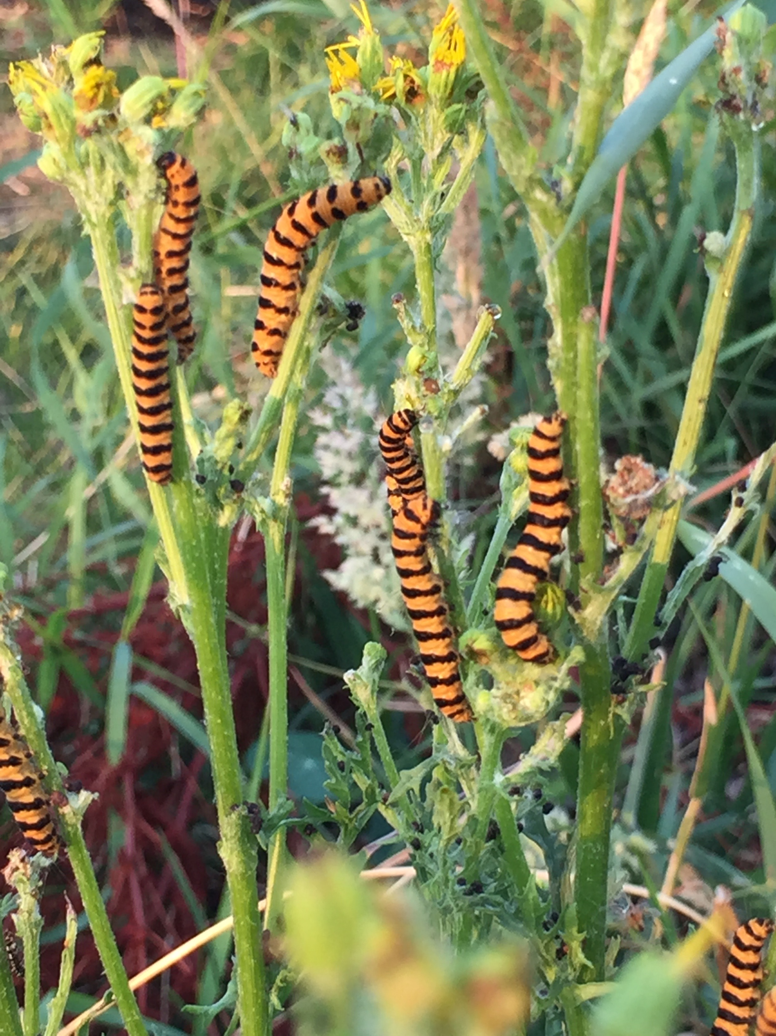
Cinnabar moth caterpillars on ragwort

I had a wonderful visit from these little tiger-like beauties this year – and all because I allowed some ragwort to grow. I am a weed friendly gardener most of the time – which might be a strange thing to say – but I liked what a permaculture friend had said once which was: ‘Weeds are just plants in the wrong place’. Watching these caterpillars lay waste to the ragwort was a sight to behold and got me looking into the ragwort controversy:

‘It is, for instance, a fact that species of Ragwort are poisonous to mammals, but it is a myth that an animal dies if it ingests only a mouthful. It is also a fact that Ragwort is poisonous to humans, but a myth that it is a serious health hazard to people. Furthermore, it is a fact that Ragwort is currently more common in the UK than 30 years ago, but a myth that this species is an extremely efficient wind disperser.
Although Ragworts can be a significant nuisance to horse keepers, these species are a very important source of nectar and pollen. About 150 species of insects, such as bees, flies and butterflies, visit the plant. Therefore, even it were possible, eradicating the plant is not a desirable option.’ (http://ragwort.org.uk)

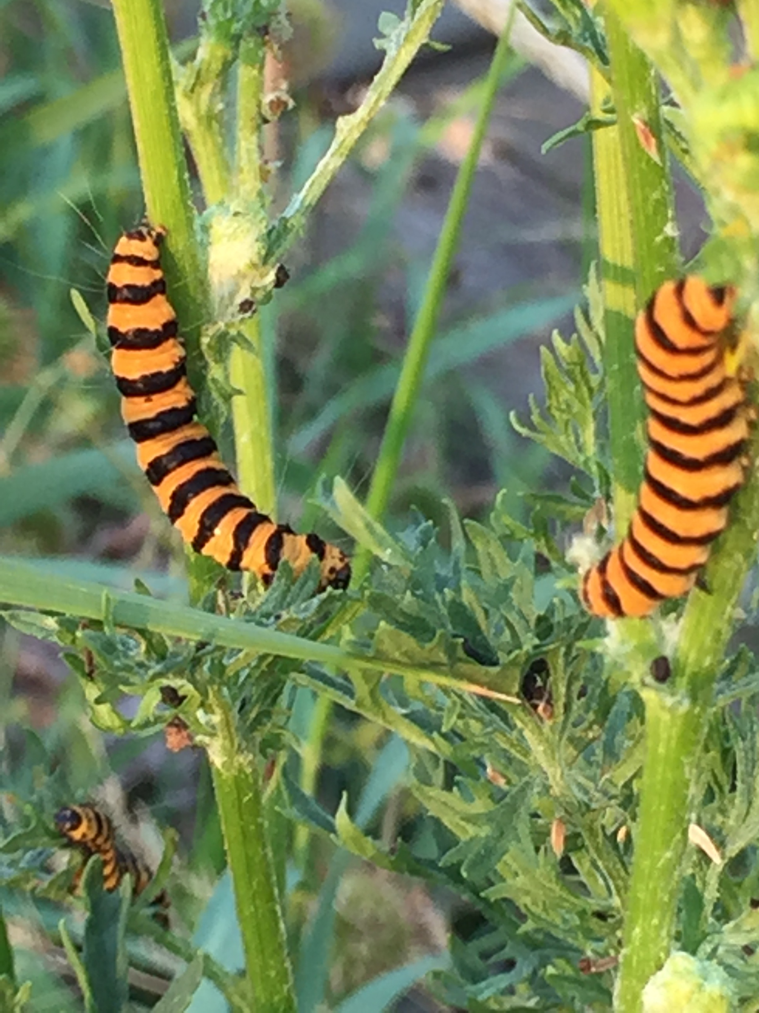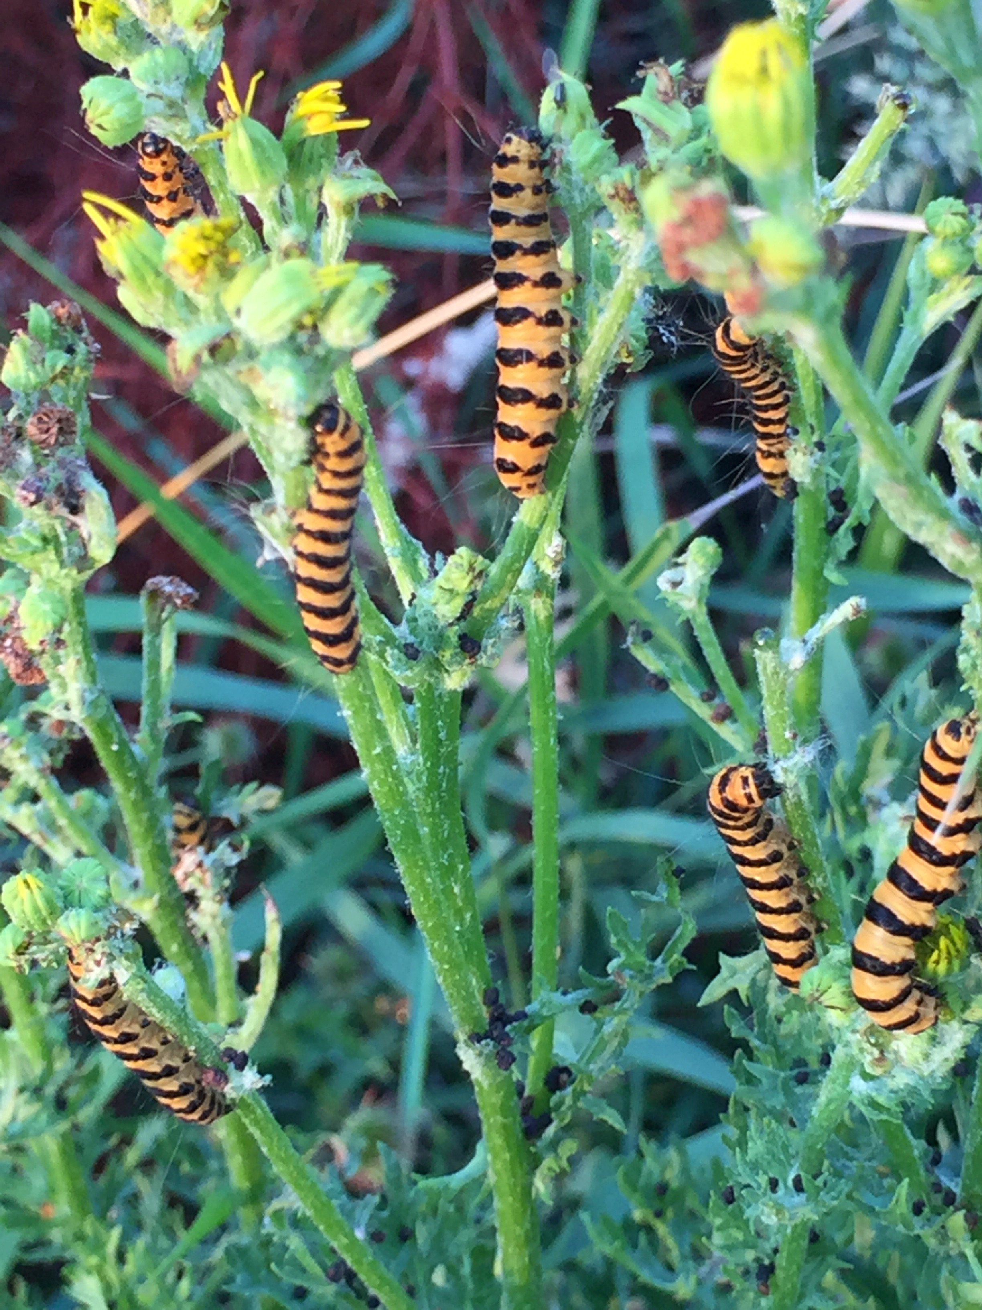
When I saw what these caterpillars did to the plant and flowers it seems like they are nature’s most perfect way to keep the plant in check.
‘Numerous caterpillars on one ragwort plant can reduce it to a bare stem very quickly. The caterpillars overwinter as pupa in a cocoon under the ground. The adult moths emerge around mid May and are on the wing up until early August, during which time males and females will mate and eggs are laid.’
(https://www.buglife.org.uk/bugs-and-habitats/cinnabar-moth)

I will keep an eye out for next May to see if the over-wintered pupae emerge as these beautiful Cinnabar moths. To ensure I don’t spoil their chances of survival I will try not to ‘tidy up’ too much around my beds.

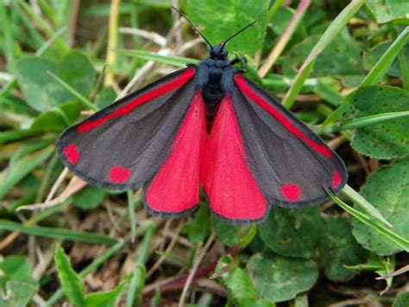 cinnabar moth

Lasagne gardening

After that amazing hot summer here are some thoughts about gardening with less watering and no digging. The method here is called ‘Lasagne Gardening’ It is a perfect way to start a new bed on an overgrown or grass covered patch. You start right on top of the grass or weeds with a layer of cardboard or newspaper:

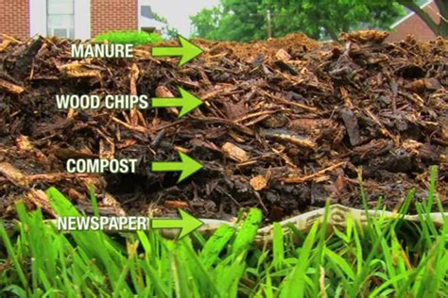

On top of that you sprinkle water then layer a green layer – like un-rotted kitchen waste, or coffee grounds or manured hay (like the delivery we get from the Palace) -then a layer of wood chippings. Carry on layering like that and watering between the layers until you have about 2 ft of lasagne layers. Finally, cover with a weed blocking material or some topsoil and well rotted manure and leave until the spring when it will be an excellent bed in which to first grow courgettes and squash.
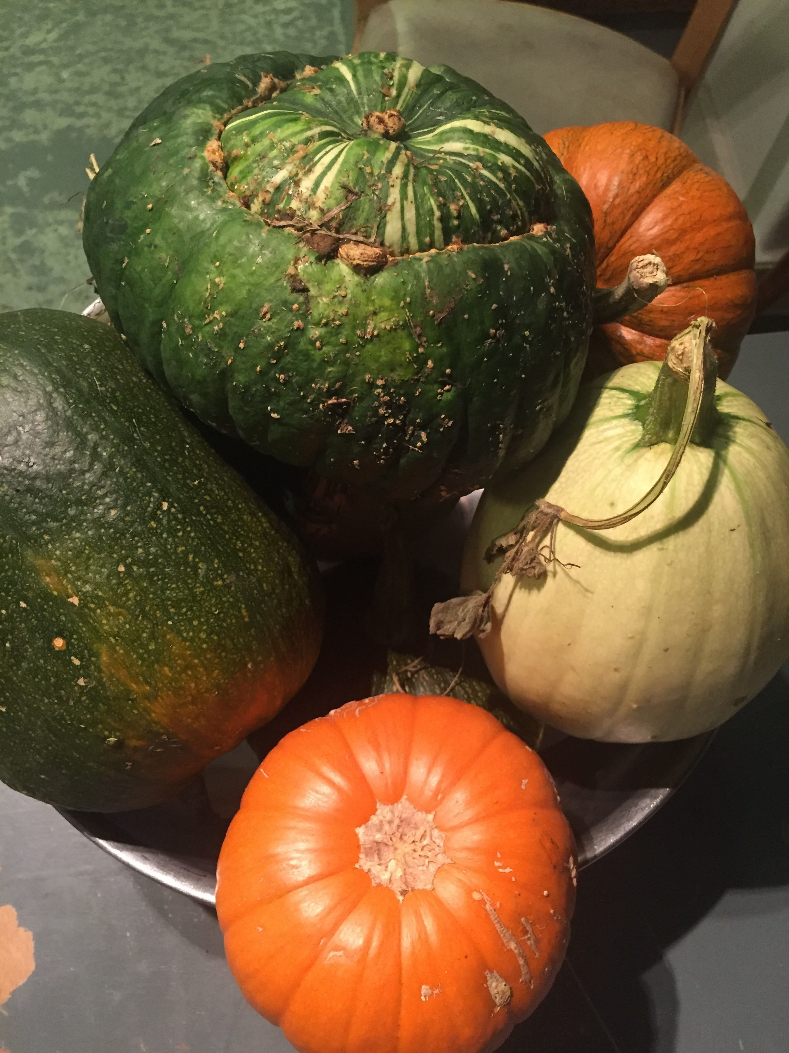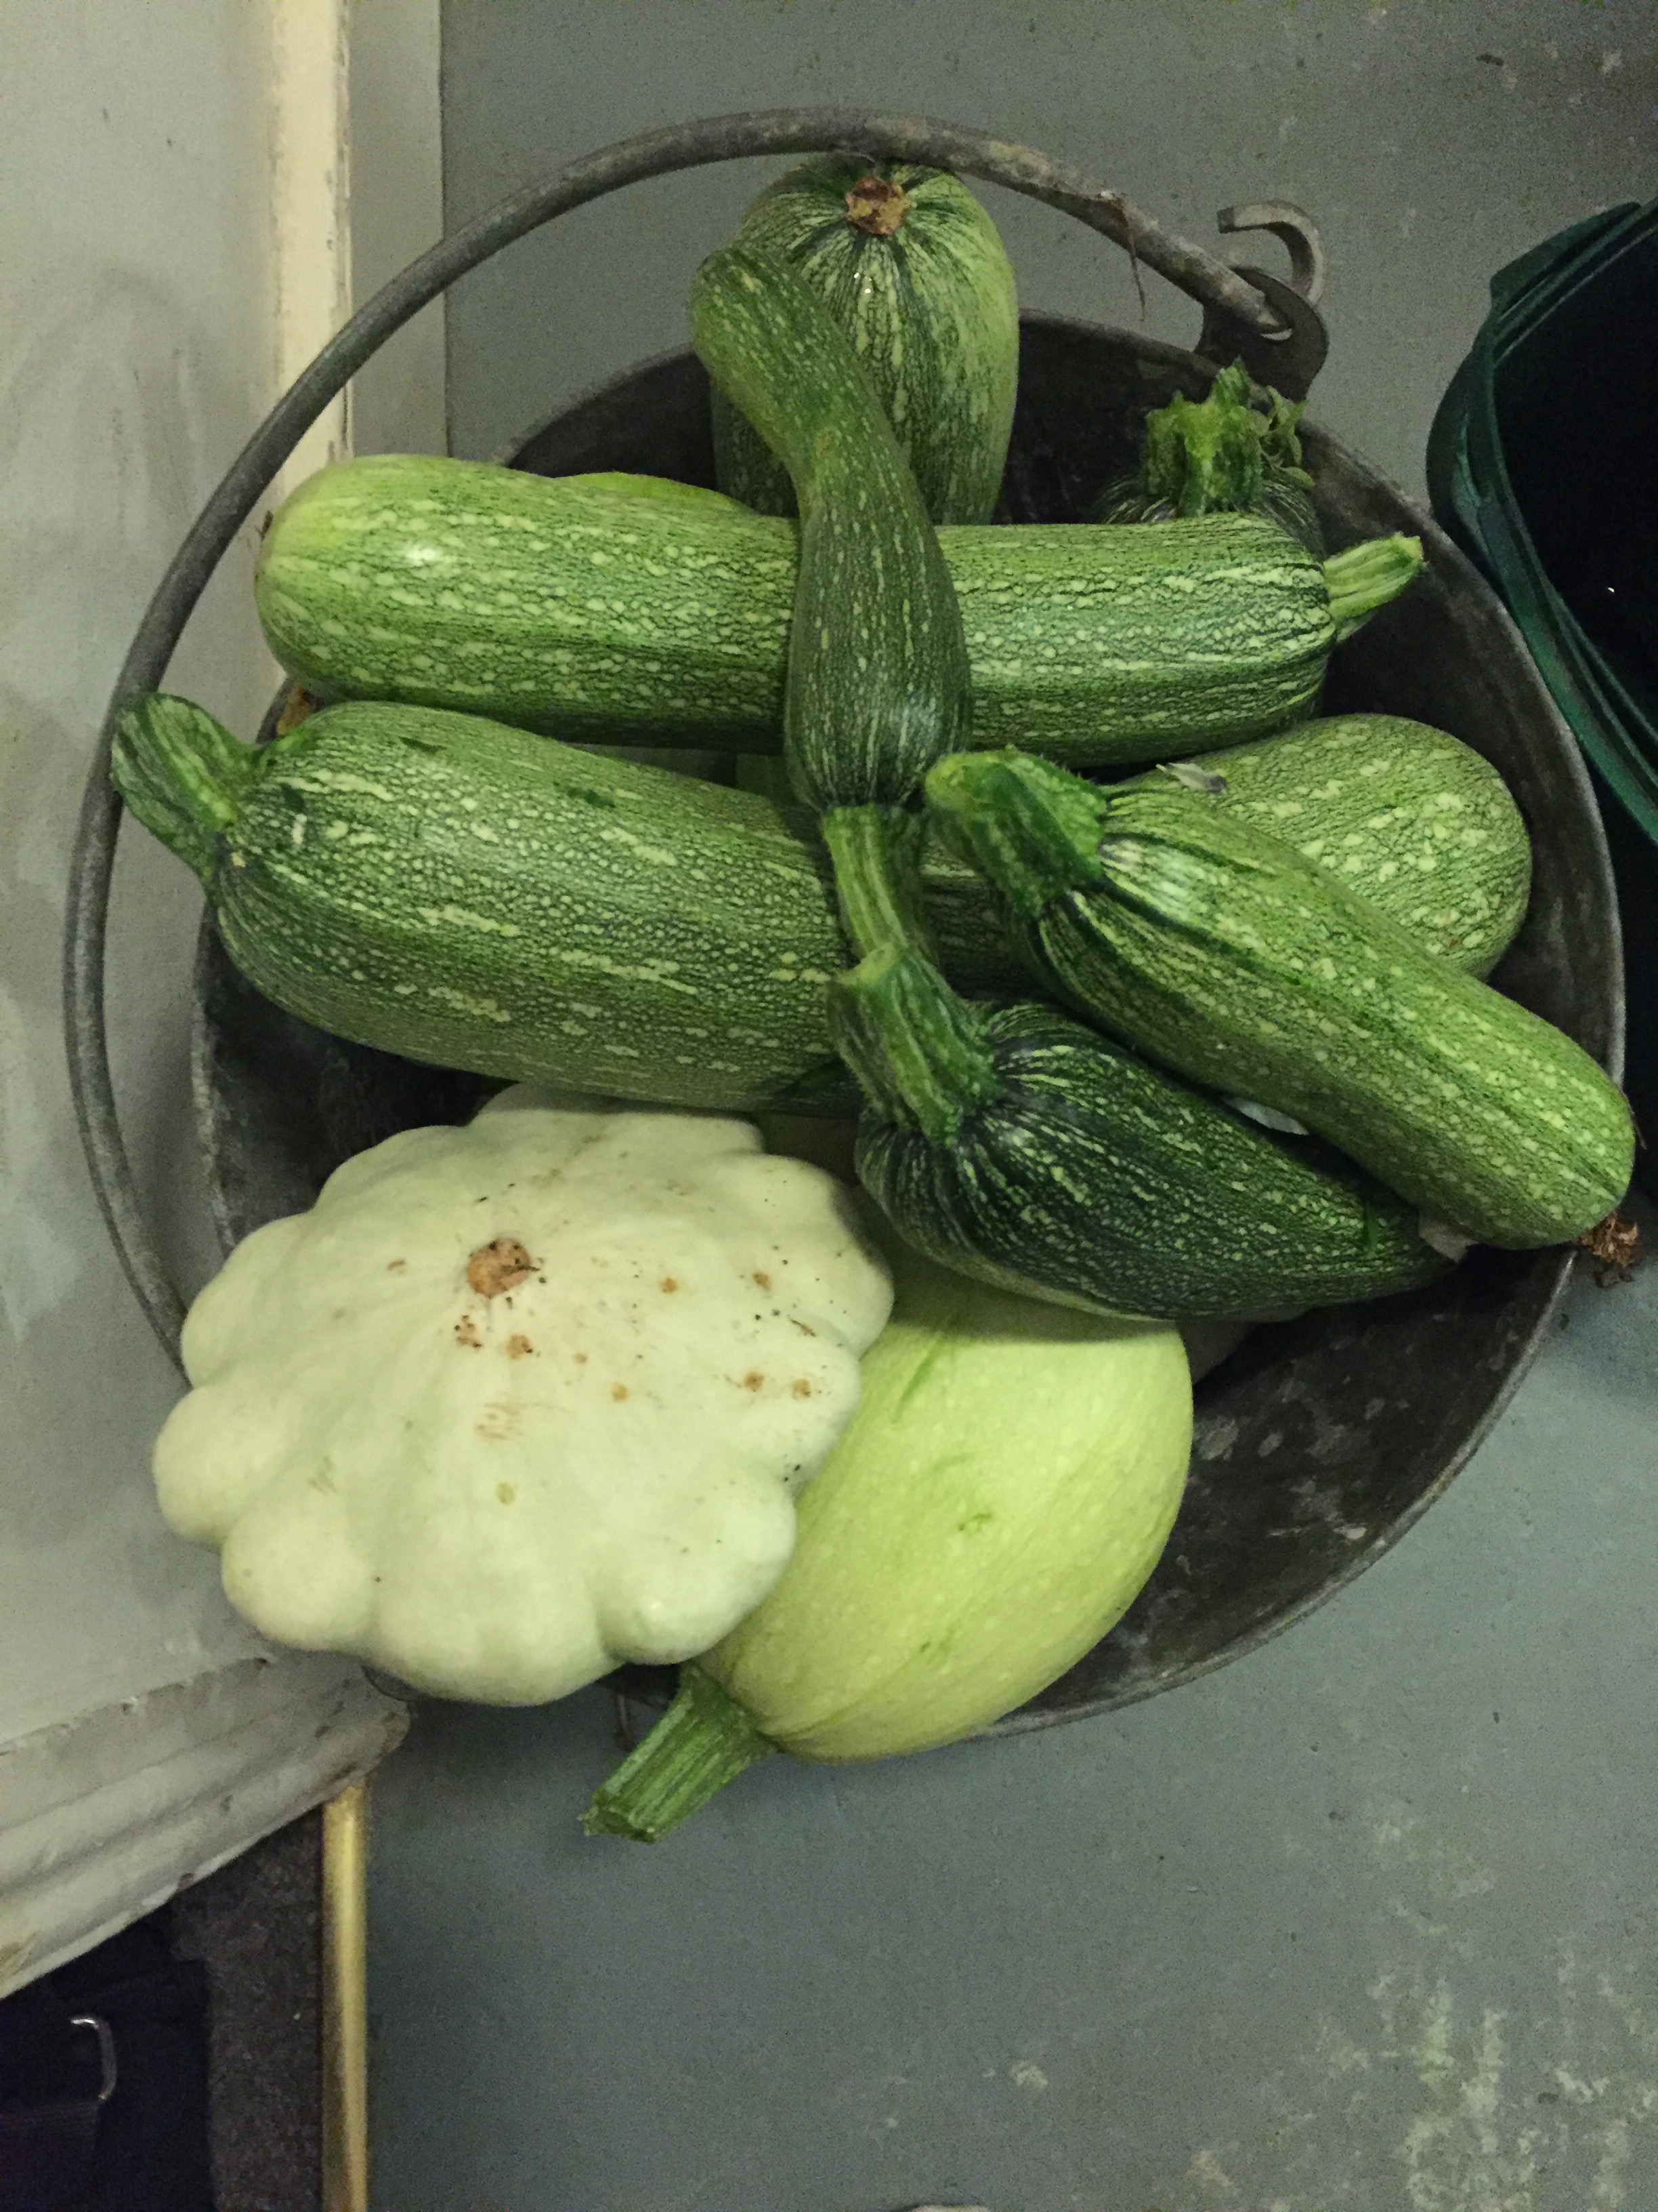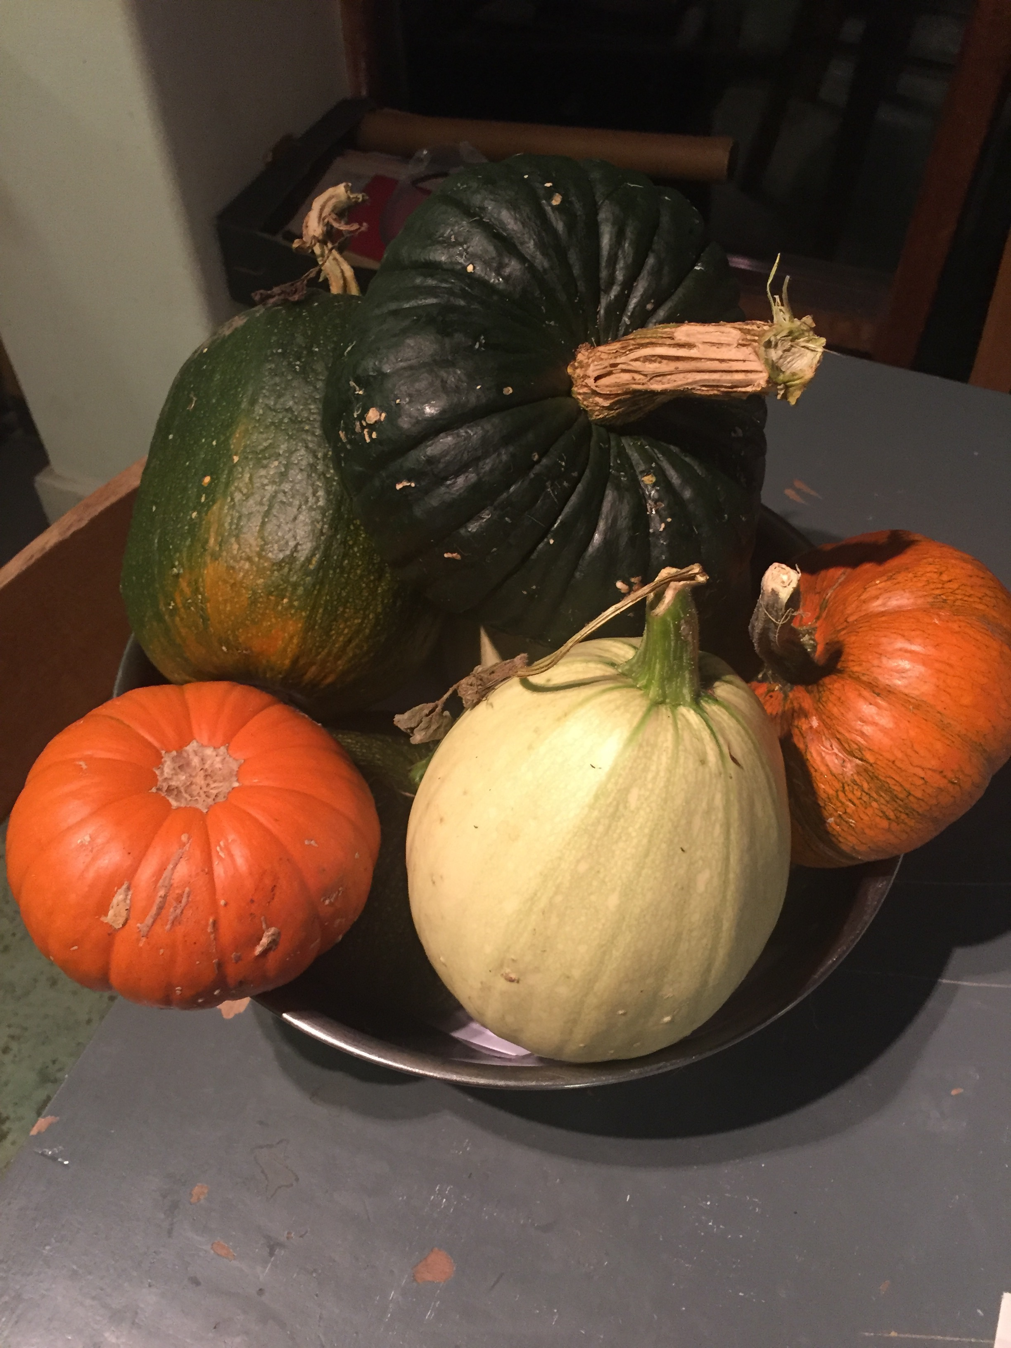

One word of warning : if you use a layer of household kitchen waste in your lasagna bed – beware of foxes digging the whole bed up to get at the compost. As foxes are so prevalent in our allotments, and their feces carry diseases which our pets are often treated for, it is not advisable to feed the foxes as it encourages them to defecate around our vegetables. They are lovely to watch skidding through the allotments on a summer’s evening but their ‘spray’ is a lot less palatable than the dogs and cats we have in our homes.

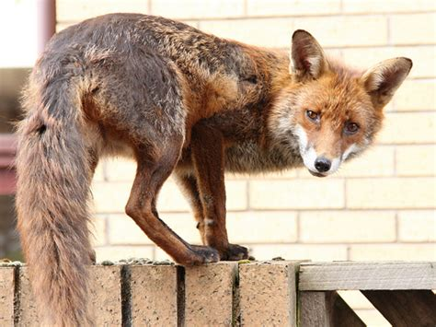
PIP PIP!
Rix Pyke 2018

